**COMPUTER HARDWARE**

Computer hardware is the physical components that a computer system requires to function. It encompasses everything with a circuit board that operates within a PC or laptop; including the motherboard, graphics card, CPU (Central Processing Unit), ventilation fans, webcam, power supply, and so on.

Although the design of hardware differs between desktop PCs and laptops due to their differences in size, the same core components will be found in both. Without hardware, there would be no way of running the essential software that makes computers so useful. Software is defined as the virtual programs that run on your computer; that is, operating system, internet browser, word-processing documents, etc.

Although a computer can function only when both hardware and software are working together, the speed of a system will largely rely on the hardware used.

When building up a new computer, or simply replacing old parts, you may need to know the specific hardware in your computer. The purpose of this guide is therefore to help you understand the inner-workings of your computer.

**MOTHER BOARD**

The motherboard is at the center of what makes a PC work. It houses the CPU and is a hub that all other hardware runs through. The motherboard acts as a brain; allocating power where it’s needed, communicating with and coordinating across all other components – making it one of the most important pieces of hardware in a computer.

When choosing a motherboard, it’s important to check what hardware ports the motherboard supplies. It’s vital to check how many USB ports, and what grade (USB 2.0, 3.0, 3.1) they are, as well as what display ports are used (HDMI, DVI, RGB) and how many of each there are. The ports on the motherboard will also help you define what other hardware will be compatible with your computer, such as what type of RAM and graphics card you can use.

Although the motherboard is just one piece of circuitry, it is home to another one of the most important pieces of hardware: the processor.

The motherboard is mounted inside the case and is securely attached via small screws through pre-drilled holes. Motherboard contains ports to connect all of the internal components. It provides a single socket for CPU, whereas for memory, normally one or more slots are available. Motherboards provide ports to attach the floppy drive, hard drive, and optical drives via ribbon cables. Motherboard carries fans and a special port designed for power supply.

There is a peripheral card slot in front of the motherboard using which video cards, sound cards, and other expansion cards can be connected to the motherboard.

On the left side, motherboards carry a number of ports to connect the monitor, printer, mouse, keyboard, speaker, and network cables. Motherboards also provide USB ports, which allow compatible devices to be connected in plug-in/plug-out fashion. For example, pen drive, digital cameras, etc.

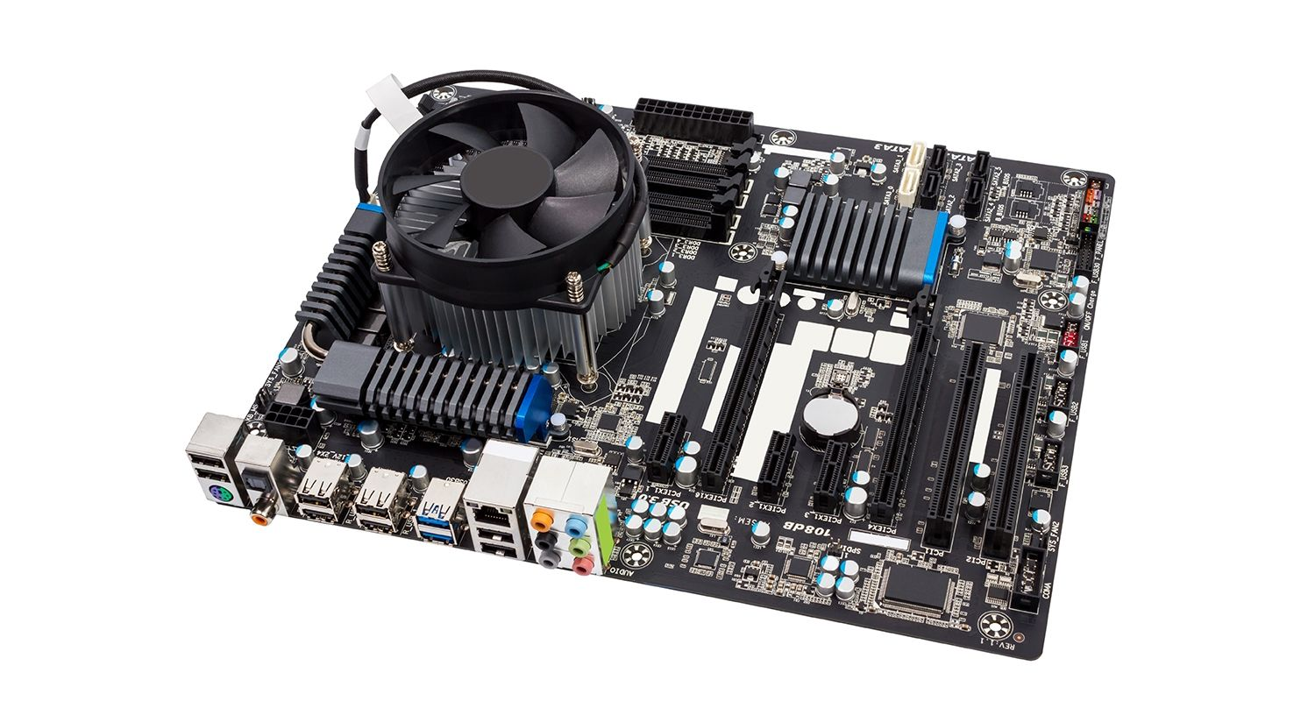

**Features of Motherboard**

A motherboard comes with following features −

* Motherboard varies greatly in supporting various types of components.
* Motherboard supports a single type of CPU and few types of memories.
* Video cards, hard disks, sound cards have to be compatible with the motherboard to function properly.
* Motherboards, cases, and power supplies must be compatible to work properly together.

**Popular Manufacturers**

Following are the popular manufacturers of the motherboard.

* Intel
* ASUS
* AOpen
* ABIT
* Biostar
* Gigabyte
* MSI

## RAM MODULES

Random Access Memory, or RAM, is hardware found in the memory slots of the motherboard. The role of RAM is to temporarily store on-the-fly information created by programs and to do so in a way that makes this data immediately accessible. The tasks that require random memory could be; rendering images for graphic design, edited video or photographs, multi-tasking with multiple apps open (for example, running a game on one screen and chatting via Discord on the other).

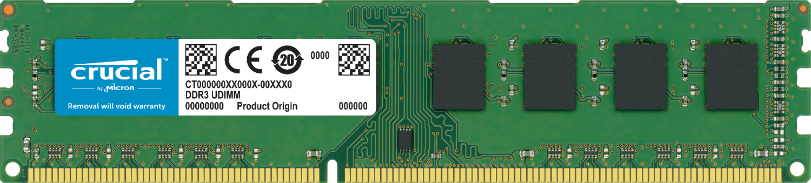

How much RAM you require depends on the programs that you’ll be running. Medium intensity gaming generally uses 8GB of memory when performed alongside other programs, but video/graphic design can use upwards of 16GB of RAM.

A **memory module** or **RAM (**[**random-access memory**](https://en.wikipedia.org/wiki/Random-access_memory)**) stick** is a [printed circuit board](https://en.wikipedia.org/wiki/Printed_circuit_board) on which [memory](https://en.wikipedia.org/wiki/Computer_memory) [integrated circuits](https://en.wikipedia.org/wiki/Integrated_circuit) are mounted.[[1]](https://en.wikipedia.org/wiki/Memory_module#cite_note-1) Memory modules permit easy installation and replacement in electronic systems, especially computers such as [personal computers](https://en.wikipedia.org/wiki/Personal_computer), [workstations](https://en.wikipedia.org/wiki/Workstation), and [servers](https://en.wikipedia.org/wiki/Server_(computing)). The first memory modules were proprietary designs that were specific to a model of computer from a specific manufacturer. Later, memory modules were standardized by organizations such as [JEDEC](https://en.wikipedia.org/wiki/JEDEC) and could be used in any system designed to use them.

Types of memory module include:

* [TransFlash Memory Module](https://en.wikipedia.org/wiki/TransFlash_Memory_Module)
* [SIMM](https://en.wikipedia.org/wiki/SIMM), a single in-line memory module
* [DIMM](https://en.wikipedia.org/wiki/DIMM), dual in-line memory module
  + [Rambus](https://en.wikipedia.org/wiki/Rambus) memory modules are a subset of DIMMs, but are normally referred to as RIMMs
  + [SO-DIMM](https://en.wikipedia.org/wiki/SO-DIMM), small outline DIMM, a smaller version of the DIMM, used in laptops

**DAUGHTER CARD**

A daughterboard (or *daughter board* , *daughter card* , or *daughtercard* ) is a circuit board that plugs into and extends the circuitry of another circuit board. The other circuit board may be the computer's main board (its motherboard ) or it may be another board or card that is already in the computer, often a sound card. The term is commonly used by manufacturers of wavetable daughterboards that attach to existing sound cards. Modern computers rarely have daughterboards. In the past, this was common. A computer's motherboard was basically just a bus with a whole bunch of card slots on it, and the processor would be on one daughter card, the memory would be on another daughter card, I/O ports would be in another daughter card, and so on.

I once owned a North Star Horizon, an S-100 bus computer. The motherboard was an S-100 bus, a standardized board that just had some bus logic on it but nothing else. You'd buy daughter cards with processors on them (and you could get all kinds; the Horizon used a Z-80 processor, but you could buy daughter cards with other processor types), cards with RAM, cards with floppy disk controllers, cards with I/O ports, and so on.

Here are some daughter cards for an S-100 motherboard:

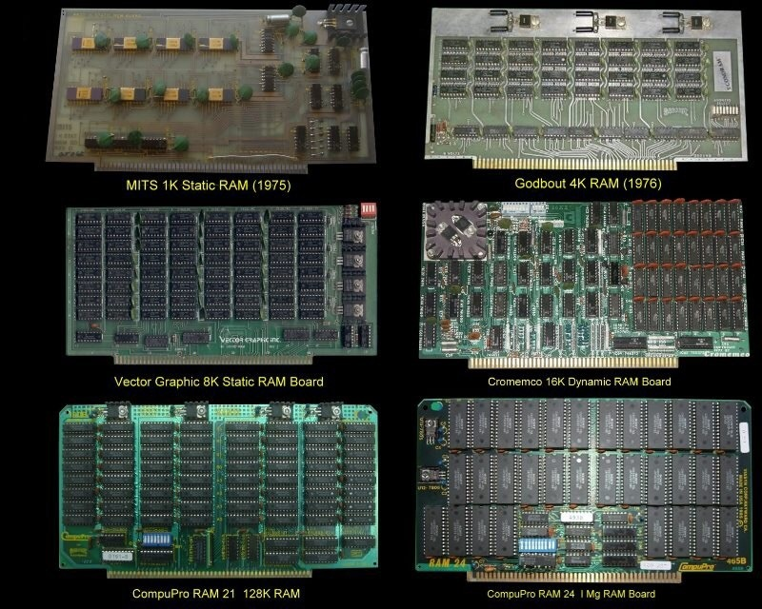

**BUS SLOT**

Alternatively known as a bus **slot** or expansion port, an expansion slot is a connection or port inside a [computer](https://www.computerhope.com/jargon/c/computer.htm) on the [motherboard](https://www.computerhope.com/jargon/m/mothboar.htm) or [riser card](https://www.computerhope.com/jargon/r/risecard.htm). It provides an installation point for a hardware expansion card to be connected. For example, if you wanted to install a new video card in the computer, you'd purchase a video expansion card and install that card into the compatible expansion slot.

The picture below is an example of what expansion slots may look like on a motherboard. In this picture, there are three different types of expansion slots: PCI Express, PCI, and AGP.

[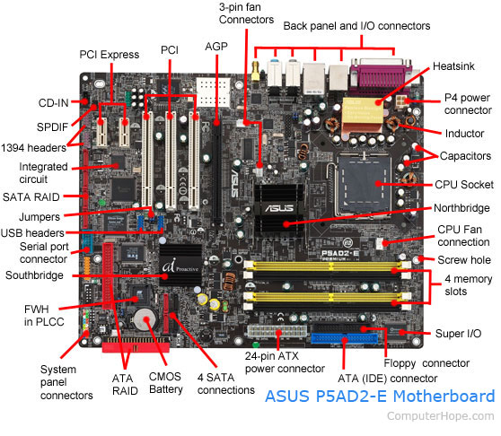](https://www.computerhope.com/cdn/bigmb.jpg)

Every computer motherboard is different, to determine how many expansion slots are on your computer motherboard identify the manufacturer and model of the motherboard. Once you've identified the model of motherboard, you can find complete information about the motherboard in its manual.

# **SWITCHED MODE POWER SUPPLY (SMPS)**

A switched-mode power supply (SMPS) is an electronic circuit that converts power using switching devices that are turned on and off at high frequencies, and storage components such as inductors or capacitors to supply power when the switching device is in its non-conduction state.

Switching power supplies have high efficiency and are widely used in a variety of electronic equipment, including computers and other sensitive equipment requiring stable and efficient power supply.

A switched-mode power supply is also known as a switch-mode power supply or switching-mode power supply.

Switched-mode power supplies are classified according to the type of input and output voltages. The four major categories are:

* AC to DC
* DC to DC
* DC to AC
* AC to AC

A basic isolated AC to DC switched-mode power supply consists of:

* Input rectifier and filter
* Inverter consisting of switching devices such as MOSFETs
* Transformer
* Output rectifier and filter
* Feedback and control circuit

The input DC supply from a rectifier or battery is fed to the inverter where it is turned on and off at high frequencies of between 20 KHz and 200 KHz by the switching MOSFET or power transistors. The high-frequency voltage pulses from the inverter are fed to the transformer primary winding, and the secondary AC output is rectified and smoothed to produce the required DC voltages. A feedback circuit monitors the output voltage and instructs the control circuit to adjust the duty cycle to maintain the output at the desired level.

There are different circuit configurations known as topologies, each having unique characteristics, advantages and modes of operation, which determines how the input power is transferred to the output.

Most of the commonly used topologies such as flyback, push-pull, half bridge and full bridge, consist of a transformer to provide isolation, voltage scaling, and multiple output voltages. The non-isolated configurations do not have a transformer and the power conversion is provided by the inductive energy transfer.

Advantages of switched-mode power supplies:

* Higher efficiency of 68% to 90%
* Regulated and reliable outputs regardless of variations in input supply voltage
* Small size and lighter
* Flexible technology
* High power density

Disadvantages:

* Generates electromagnetic interference
* Complex circuit design
* Expensive compared to linear supplies

Switched-mode power supplies are used to power a wide variety of equipment such as computers, sensitive electronics, battery-operated devices and other equipment requiring high efficiency.

**INTERNAL STORAGE DEVICES**

**Internal** is a term used to describe a device that is installed in the computer. For example, a [video card](https://www.computerhope.com/jargon/v/video-card.htm) is an **internal device** and a [printer](https://www.computerhope.com/jargon/p/printer.htm) is an external device. When referring to a drive, an **internal drive** (e.g., [internal hard drive](https://www.computerhope.com/jargon/h/harddriv.htm)) is any drive inside the computer. In the picture is an example of computer memory and an example of internal hardware. Below are additional examples of internal hardware in a computer.

## Internal computer hardware devices

### **10 Digital Data Storage Devices for Computers**

1. Hard Drive Disks
2. Floppy Disks
3. Tapes
4. Compact Discs (CDs)
5. DVD and Blu-ray Discs
6. USB Flash Drives
7. Secure Digital Cards (SD Card)s
8. Solid-State Drives (SSDs)
9. Cloud Storage
10. Punch Cards

## 1. Hard Disk Drives

A hard disk drive (also known as a hard drive, HD, or HDD) can be found installed in almost every desktop and laptop computer. It stores files for the operating system and software programs as well as user documents, such as photographs, text files, videos, and audio. The hard drive uses magnetic storage to record and retrieve digital information to and from one or more fast-spinning disks.

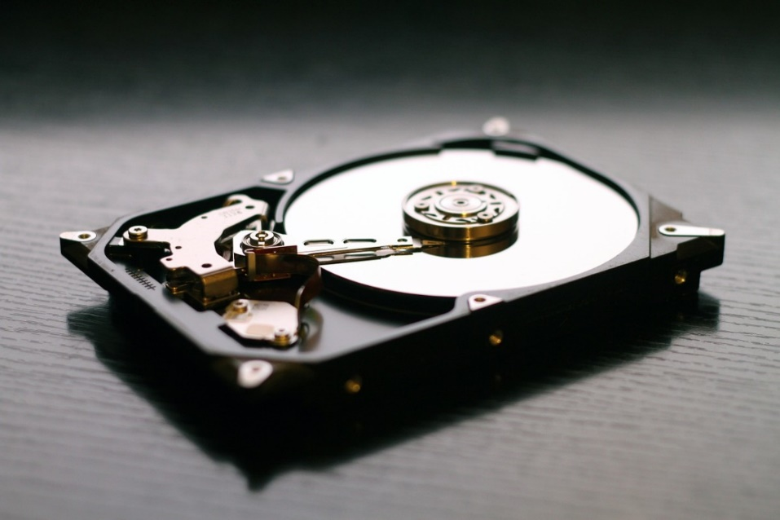

The hard disk drive in your computer probably looks something like this.

## 2. Floppy Disks

Also know as a diskette, floppy, or FD, the floppy disk is another type of storage medium that uses magnetic storage technology to store information. Floppy disks were once a common storage device for computers and were very common from the mid-1970s through to the start of the 21st century.

The earliest floppies were 8 inches (203 mm) in size, but these were replaced first by 5.25-inch (133 mm) disk drives and finally by ​3.5-inch (90 mm) versions.

## 3. Tapes

In the past, magnetic tape was often used for digital data storage because of its low cost and ability to store large amounts of data. The technology essentially consisted of a thin, magnetically coated piece of plastic wrapped around wheels. Its relative slowness and unreliability compared to other data storage solutions have resulted in it now being largely abandoned as a storage medium.

## 4. Compact Discs (CDs)

The compact disc, (or CD for short) is a form of optical storage, a technology that employs lasers and lights to read and write data. Initially, compact discs were used purely for music, but in the late 1980s, they began to be used for computer data storage.

Initially, the compact discs that were introduced were CD-ROMs (read-only), but these were followed by CD-Rs (writable compact discs) and CD-RWs (rewritable compact discs).

[[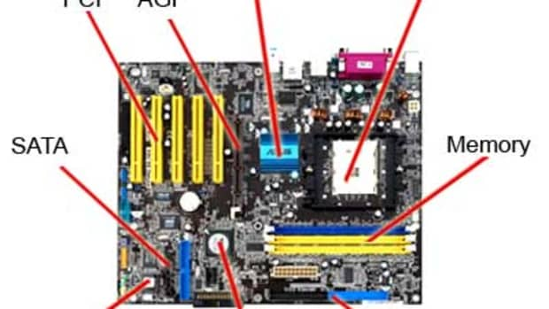](https://turbofuture.com/computers/the-motherboard-components)](https://turbofuture.com/computers/the-motherboard-components" \o "10 Parts of a Motherboard and Their Function)

[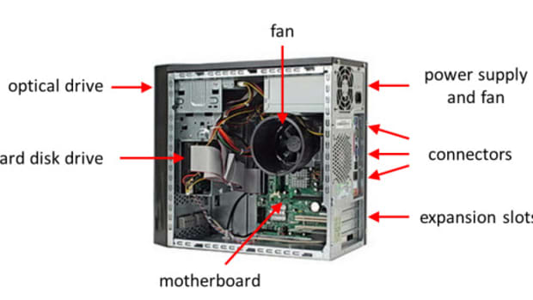](https://turbofuture.com/computers/Pcs-system-unit)

## [Overview of Computer System Unit Parts](https://turbofuture.com/computers/Pcs-system-unit)

[[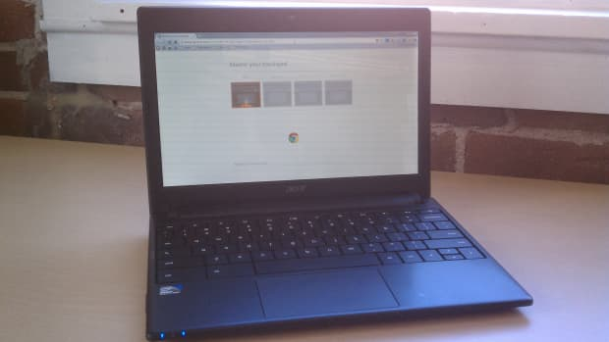](https://turbofuture.com/computers/computer-types)](https://turbofuture.com/computers/computer-types" \o "4 Examples of Different Computer Types)

## [4 Examples of Different Computer Types](https://turbofuture.com/computers/computer-types)

## 5. DVD and Blu-ray Discs

The DVD (digital versatile disc) and Blu-ray disc (BD) are formats of digital optical disc data storage which have superseded compact discs, mainly because of their much greater storage capacity.

A Blu-ray disc, for example, can store 25 GB (gigabytes) of data on a single-layer disc and 50 GB on a dual-layer disc. In comparison, a standard CD is the same physical size, but only holds 700 MB (megabytes) of digital data.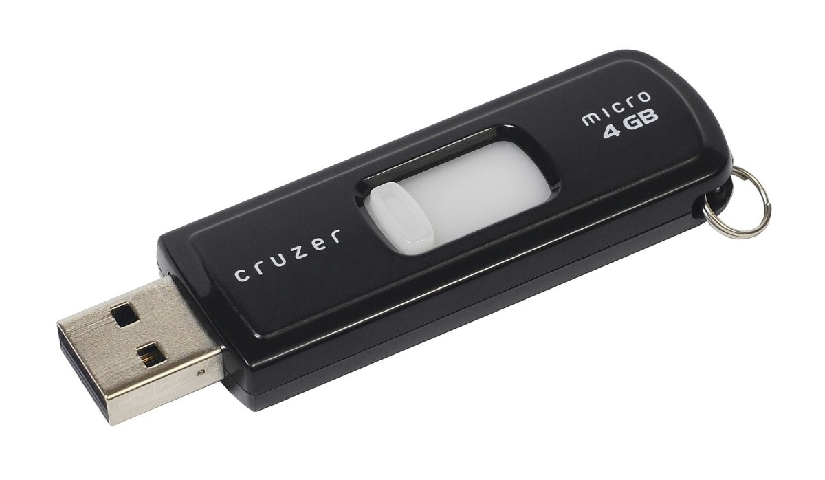

USB flash drives are often used by students and professionals to save work from one computer and continue working on it on another.

## 6. USB Flash Drives

Also known as a thumb drive, pen drive, flash drive, memory stick, jump drive, and USB stick, the USB flash drive is a flash-memory data-storage device that incorporates an integrated USB interface. Flash memory is generally more efficient and reliable than optical media, being smaller, faster, and possessing much greater storage capacity. Flash drives are also more durable due to a lack of moving parts.

## 7. Secure Digital Cards (SD Cards)

SD cards are commonly used in multiple electronic devices, including digital cameras and mobile phones. Although there are different sizes, classes, and capacities available, they all use a rectangular design with one side "chipped off" to prevent the card from being inserted into a camera or computer the wrong way.

## 8. Solid-State Drives (SSDs)

A solid-state drive uses flash memory to store data and is sometimes used in devices such as netbooks, laptops, and desktop computers instead of a traditional hard disk drive.

The advantages of an SSD over an HDD include a faster read/write speed, noiseless operation, greater reliability, and lower power consumption. The biggest downside is cost, with an SSD offering lower capacity than an equivalently priced HDD.

## 9. Cloud Storage

With users increasingly operating multiple devices in multiple places, many are adopting online cloud-computing solutions. Cloud computing basically involves accessing services over a network via a collection of remote servers.

Although the idea of a "cloud of computers" may sound rather abstract to those unfamiliar with this metaphorical concept, in practice, it can provide powerful storage solutions for devices that are connected to the internet.

10. Punch Cards

Punch cards (or punched cards) were a common method of data storage used with early computers. Basically, they consisted of a paper card with punched or perforated holes created by hand or machine. The cards were entered into computers to enable the storage and accessing of information.

This data-storage medium pretty much disappeared as new and better technologies were developed.

**INTERFACING PORTS**

Ports, used to add keyboard, monitor, printer, etc., are places to attach external devices using connectors.

**Types of Ports**

Serial Port – transmits only one bit of data at a time, used to connect things that don’t require a fast transmission time like a keyboard, mouse, or modem.

Parallel port - transmits more than one bit of data at a time, faster than serial ports. USB (universal serial bus) – can connect up to 127 different peripheral devices with a single connector

FireWire – similar to USB, can connect up to 63 different peripheral devices with a single connector serial port parallel port

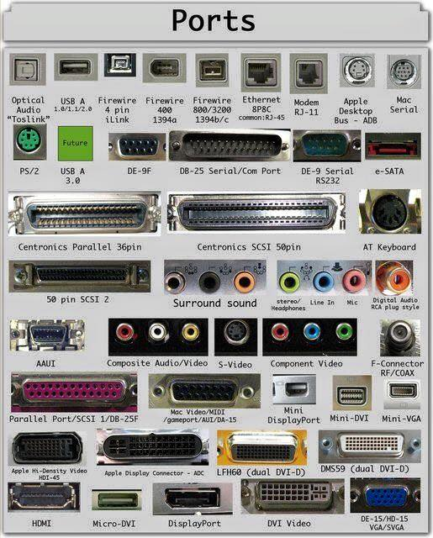

**Special Purpose Ports**

• MIDI (musical instrument digital interface)

• SCSI (small computer system interface) – high speed parallel port for disk drives and printers

• 1394 or FireWire (like USB port) – connects multiple devices

• IrDA (InfraRed Data Association) – used for wireless connections

• Bluetooth – also used for wireless, uses radio waves